The laboratory work 3

Exercise 1: Print First 10 natural numbers using while loop.

Exercise 2: Print the following pattern

Exercise 3: Accept number from user and calculate the sum of all number from 1 to a given number
For example, if user entered 10 the output should be 55.

Exercise 4: Print multiplication table of a given number
For example, num = 2 so the output should be

Exercise 5: Given a list, iterate it, and display numbers divisible by five, and if you find a number greater than 150, stop the loop iteration
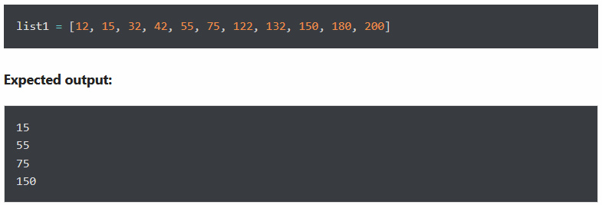

Exercise 6: Reverse the following list using for loop
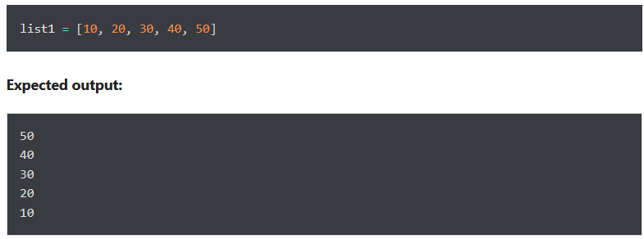

Exercise 7: Display numbers from -10 to -1 using for loop.

Exercise 8: Display a message “Done” after successful execution of for loop
For example, the following loop will execute without any error.
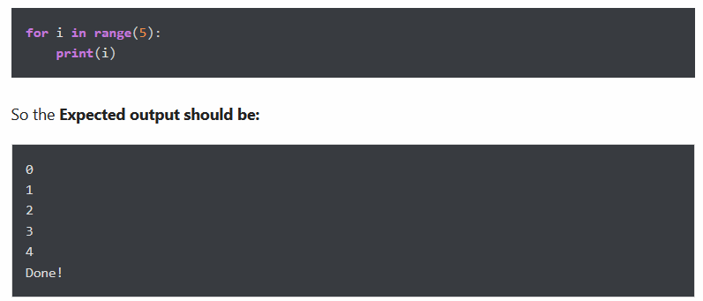

Exercise 9: Write a program to display all prime numbers within a range
Note: A Prime Number is a whole number that cannot be made by multiplying other whole numbers
Examples:
- 6 is not a Prime Number because it can be made by 2×3 = 6
- 37 is a Prime Number because no other whole numbers multiply together to make it.
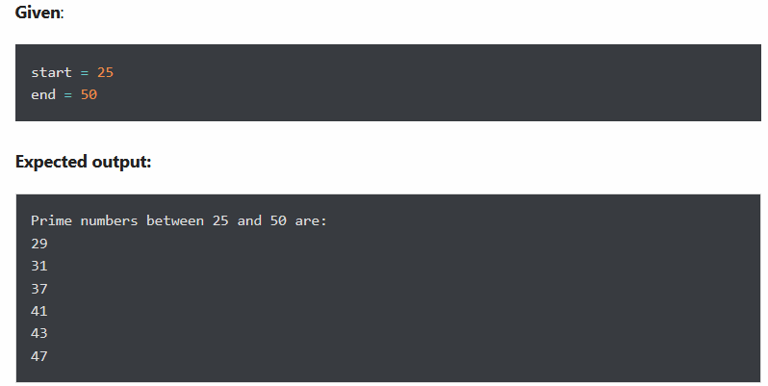

Exercise 10: Write a loop to find the factorial of any number
The factorial (symbol: !) means to multiply all whole numbers from the chosen number down to 1.
For example: calculate the factorial of 5

